AWS 8

Purpose

The BitBeat company is going to create a virtual server. In this activity we are going to build a cloud webserver, create a key pair, and SSH into the Amazon Elastic Compute Cloud instance.

Troubleshoot

The bash script in user data was formatted incorrectly, so I changed the format and deleted the extra space after lines. At the end, I successfully SSH into public IPV4 address and using putty. Successfully saw the user directory in putty.

Screenshots

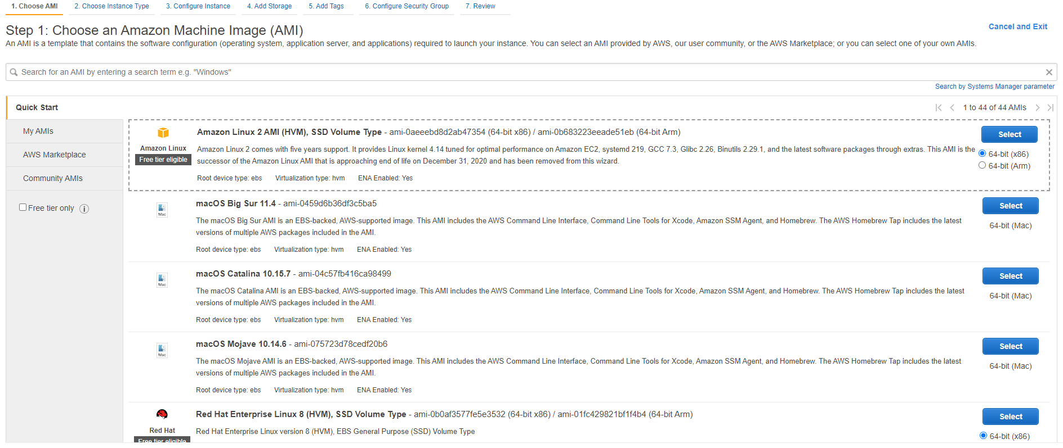

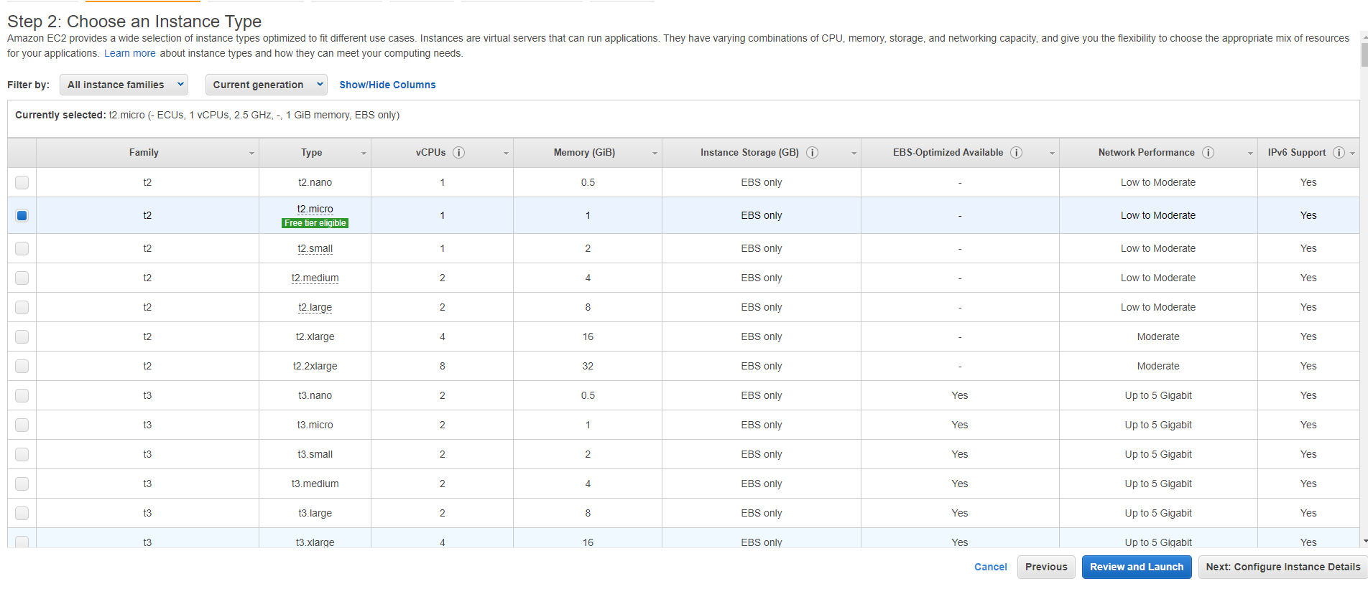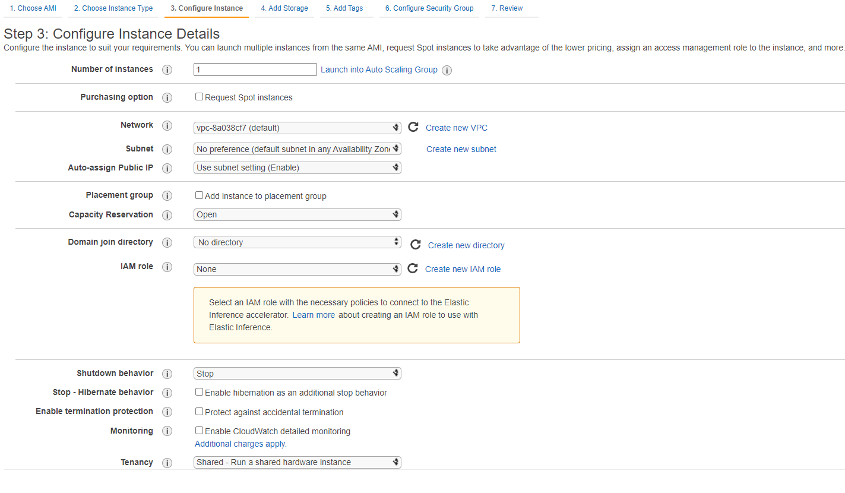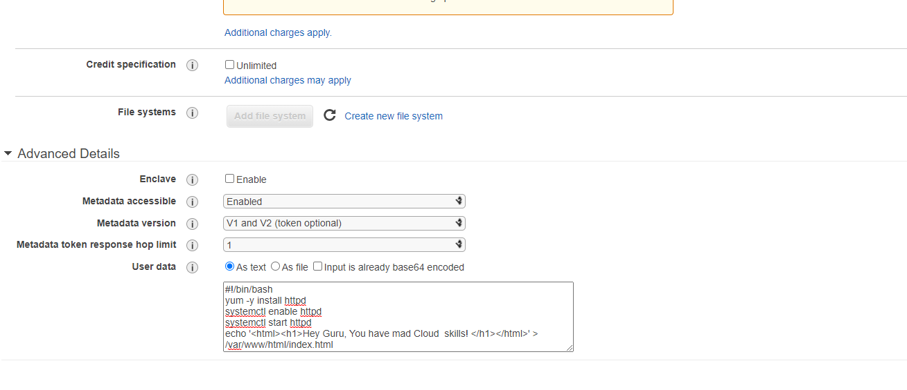

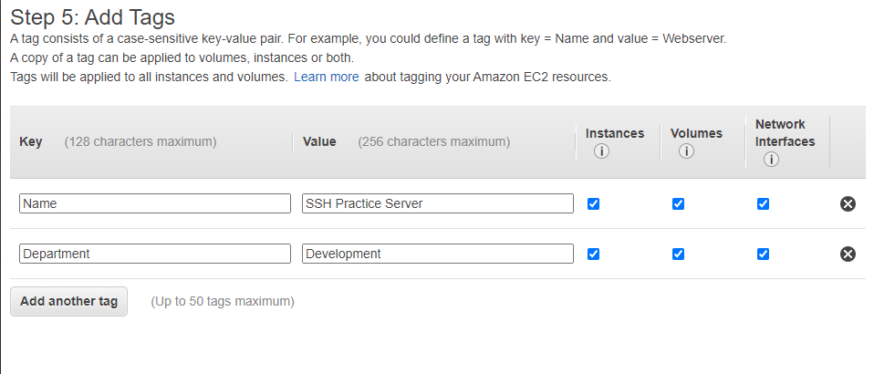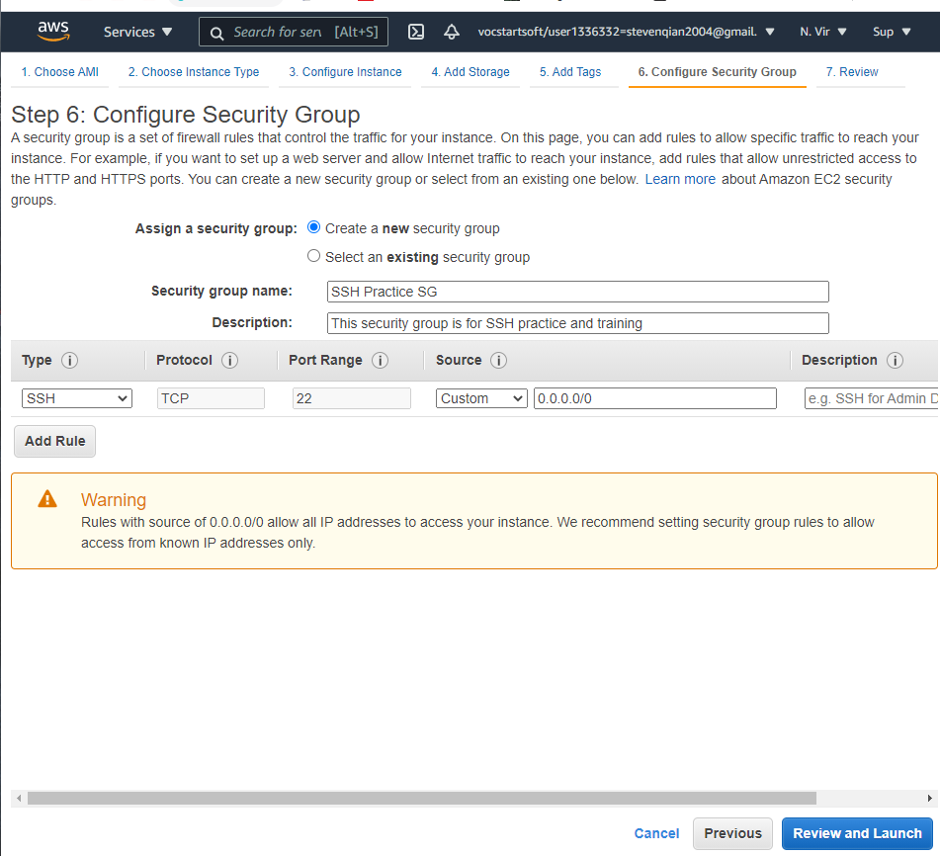

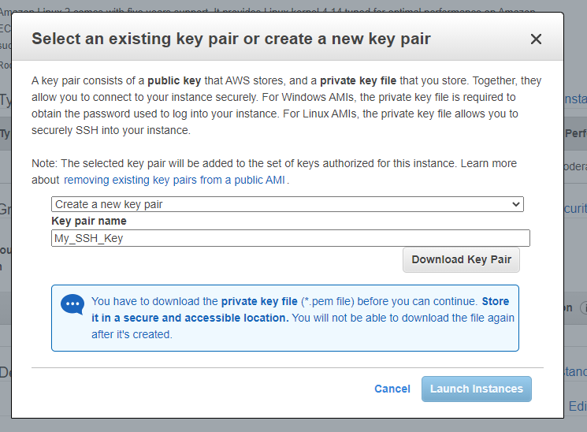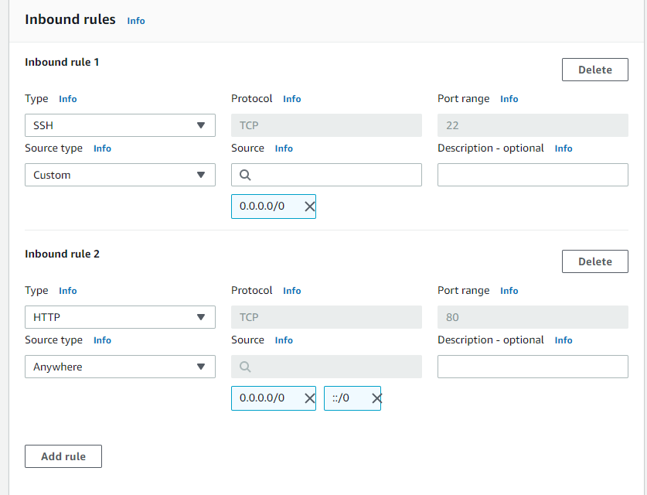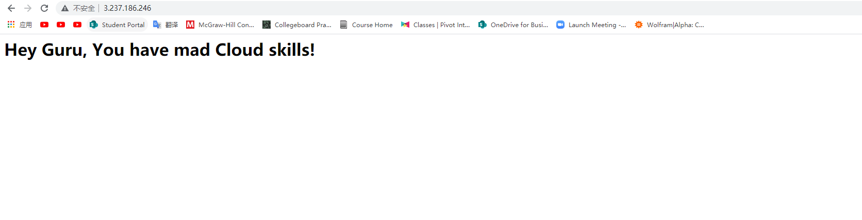

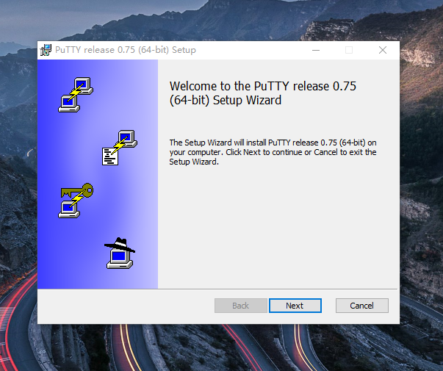

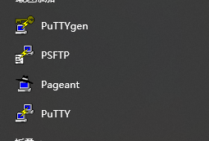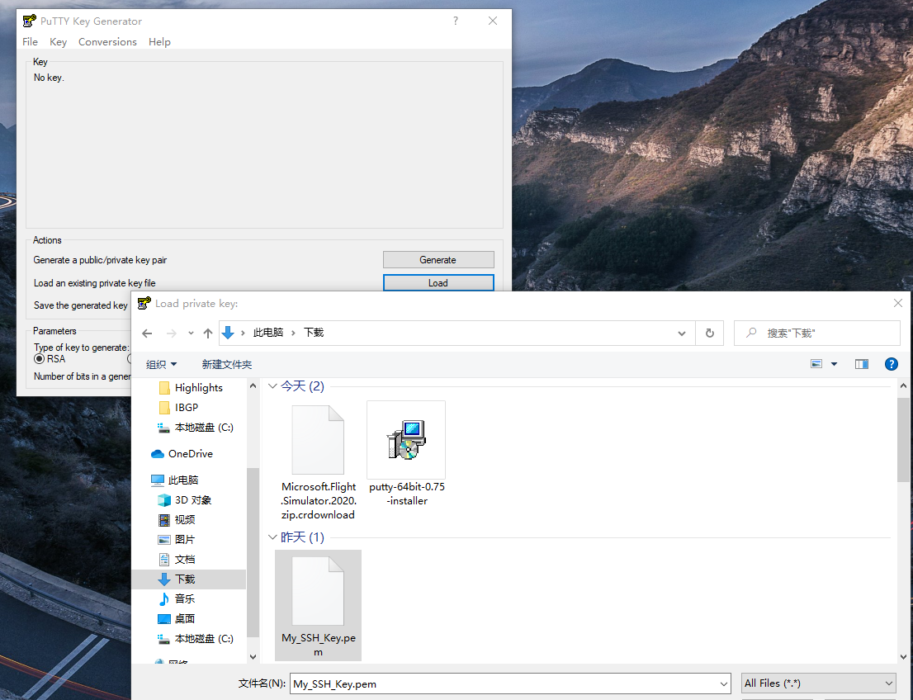

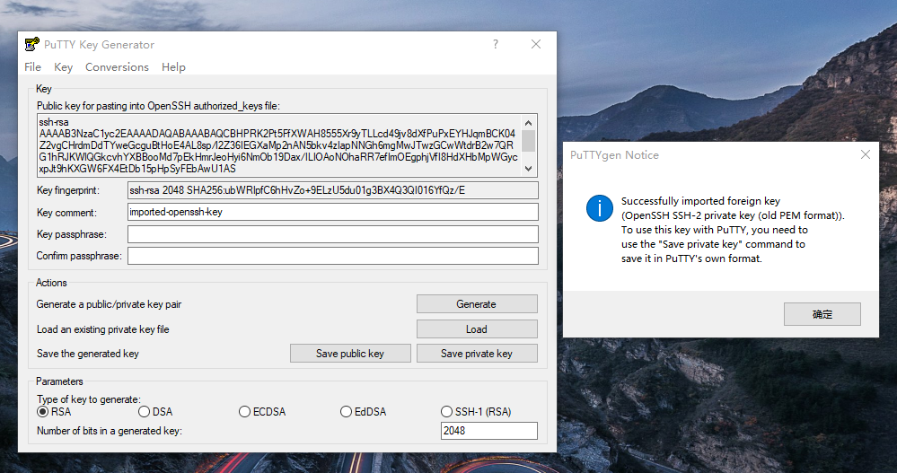

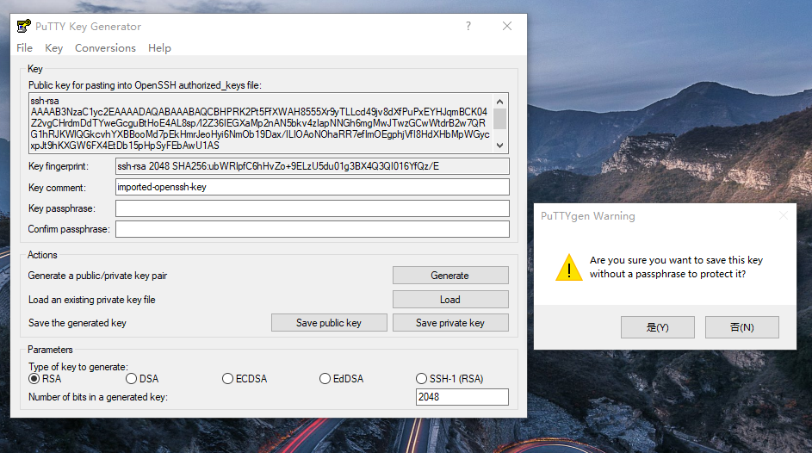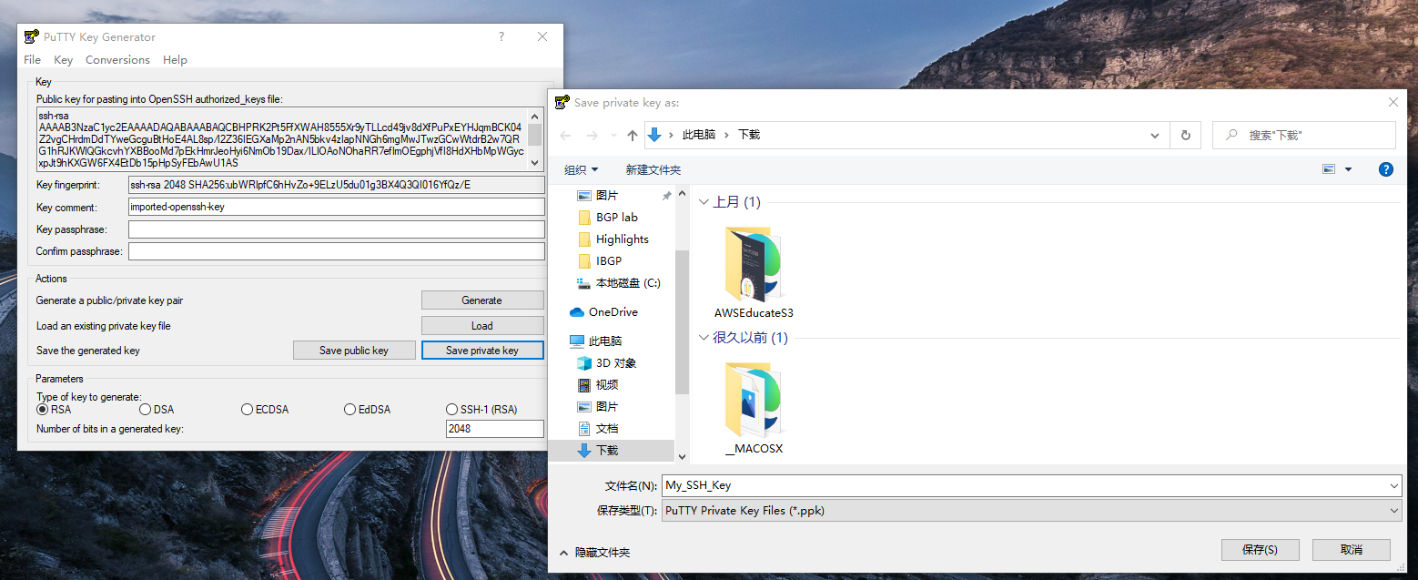

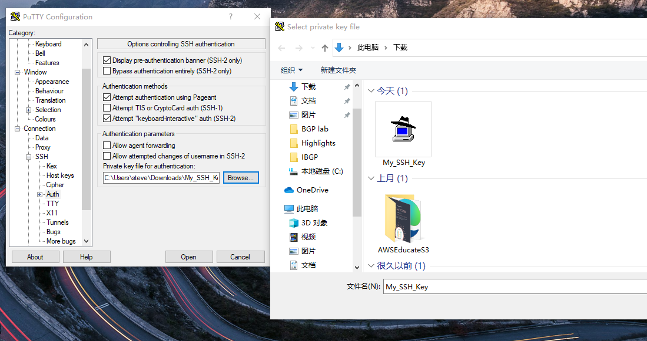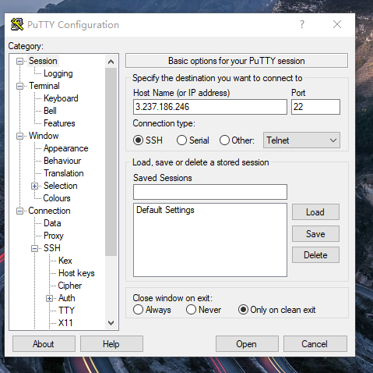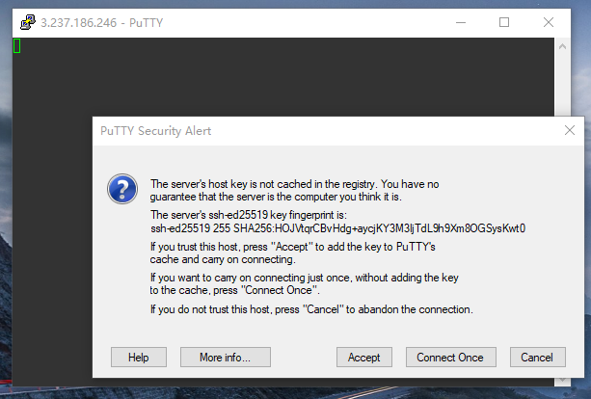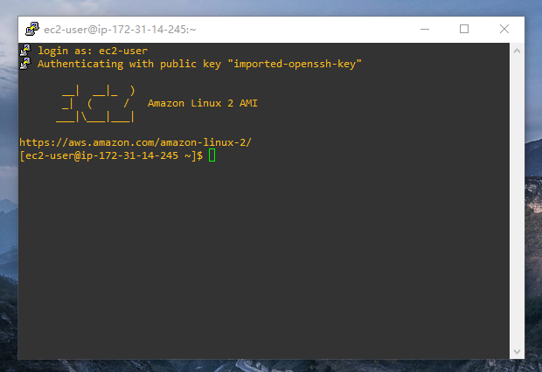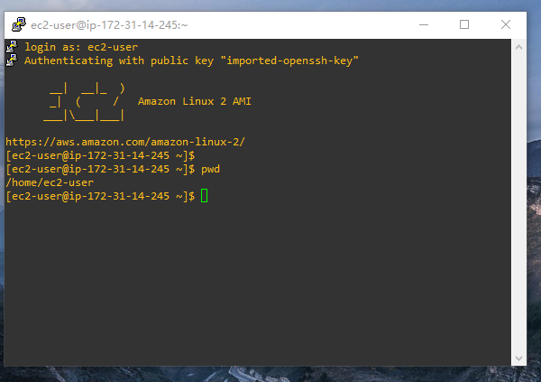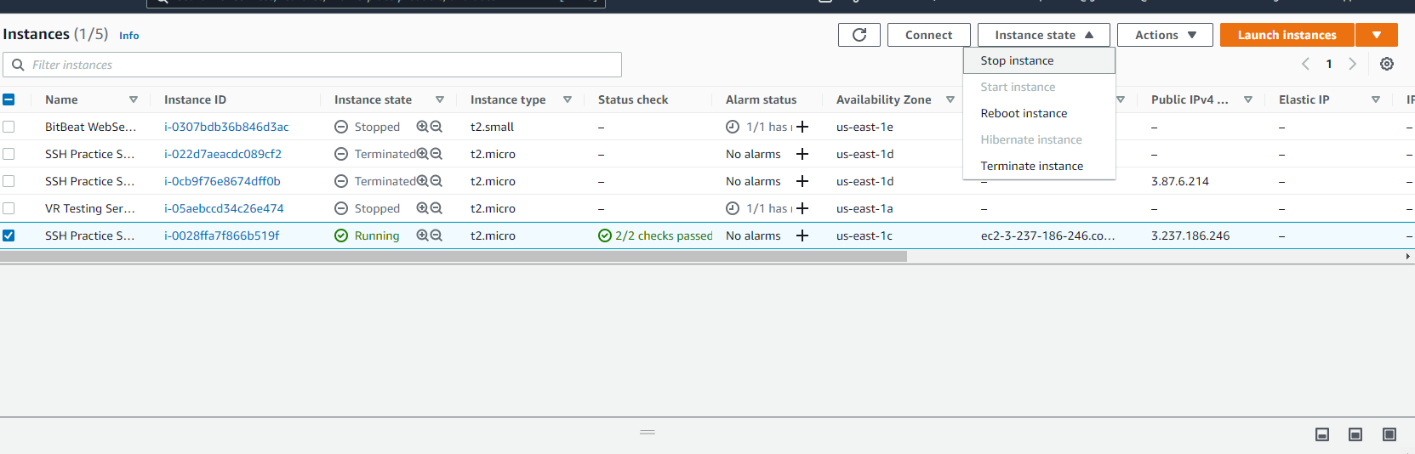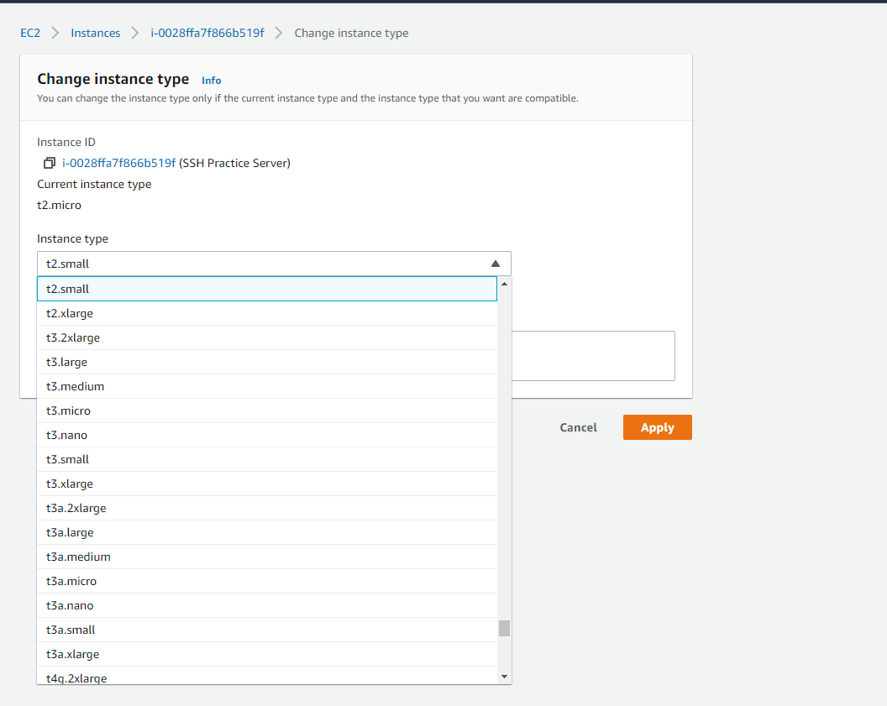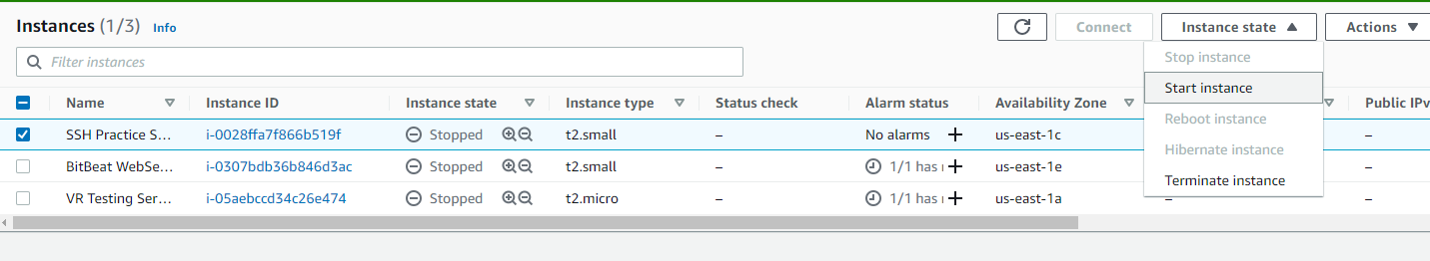

Answers

* Key pair is a set of security credentials that you use to prove your identity when connecting to an instance. Use the key pairs to securely access instances.
* Amazon EC2
* Local host
* A tag is a label that you assign to an AWS resource.
* SSH is a secure method to console into a network. SSH enables two computers to establish a secure and direct connection within a potentially unsecure network, such as the internet.
* RDP is a network communication protocol that allows users to remotely connect to another computer. It creates secure connections between clients and servers/virtual machines, and virtual desktops that are encrypted.
* 3389
* http://3.91.206.178/latest/user-data